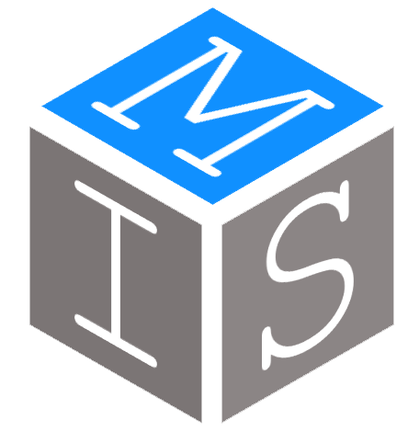

HELP GUIDE

SECTION HEAD

Login Page

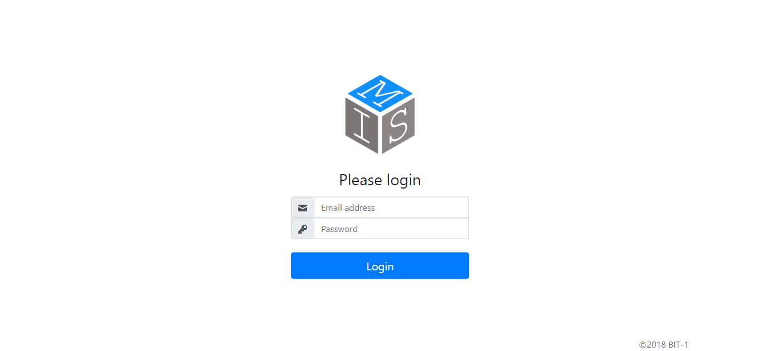

3.Press Login once e-mail, and password has been entered correctly.

2.Enter personal password.

1.Enter business e-mail address.

Dashboard

Shows the number of equipment returned the past number of days.

Shows the latest equipment received (inputted) by a Section Head.

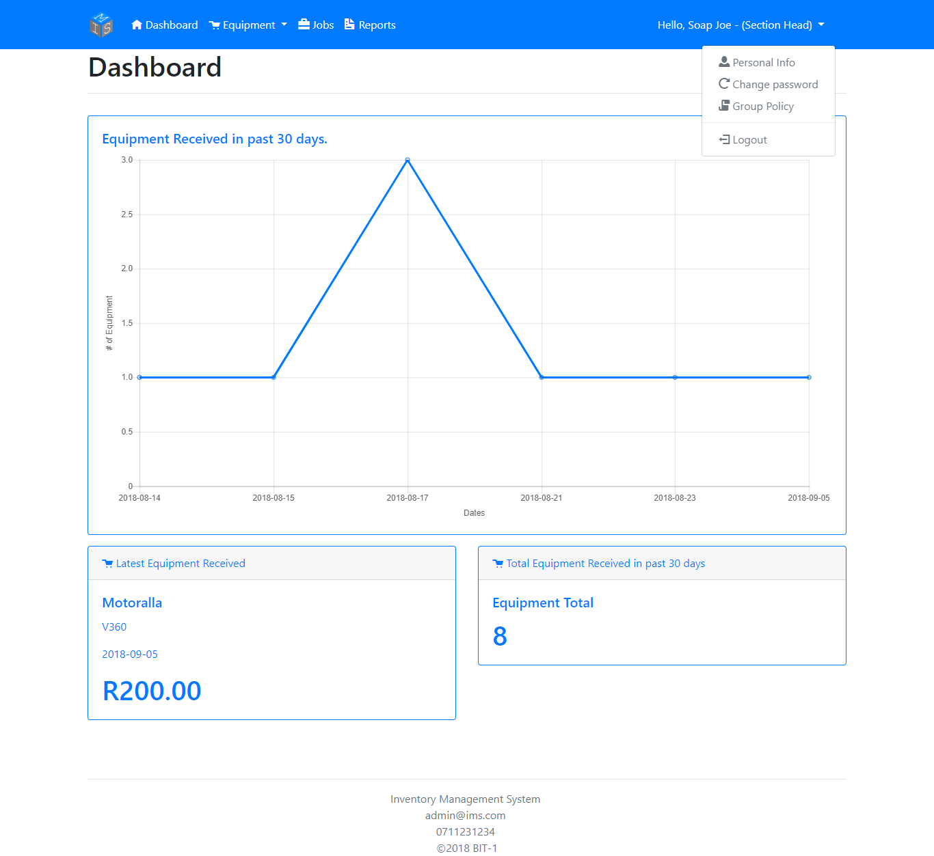

A PDF involving the business’s Group Policy will get downloaded onto your device.

Press ‘Filter’ to filter the number of equipment received the last 7, 14, or 30 days. Press ‘Reset’ to return to default.

To get redirected to the page that will allow you to change your personal details.

To get redirected to the page that will allow you to reset your password.

Update Personal Info

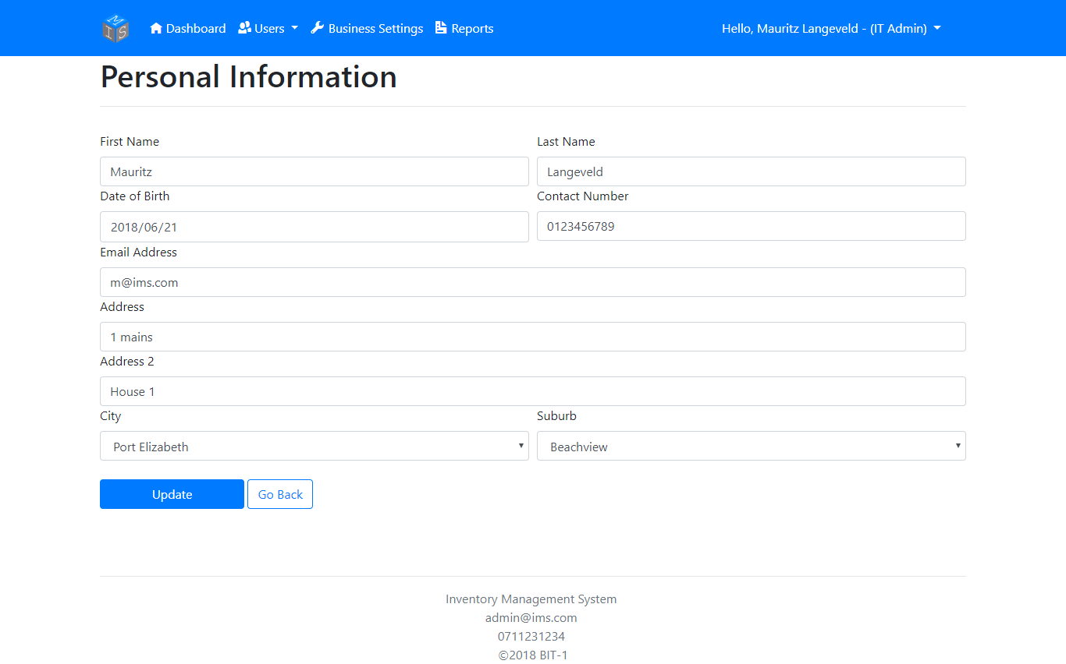

a. Suburb dropdown won’t load unless the user has selected a City.

b. If neither the new user’s City or their Suburb exist in the dropdown, press the ‘Add New City/Suburb’ selection located in the respected dropdown.

Click ‘Update’ to update your personal information.

Change Password

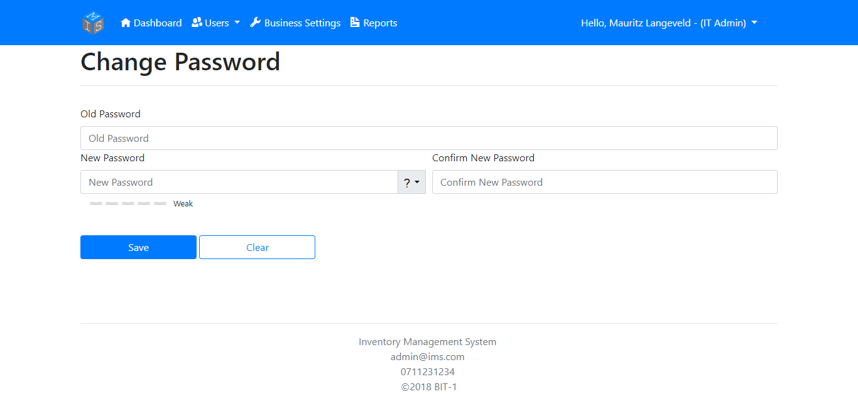

Press ‘Clear’ to erase all fields.

Press ‘Save’ to change your password

Enter your new password here…

Re-enter your new password here…

Enter your current password here…

Receive Equipment

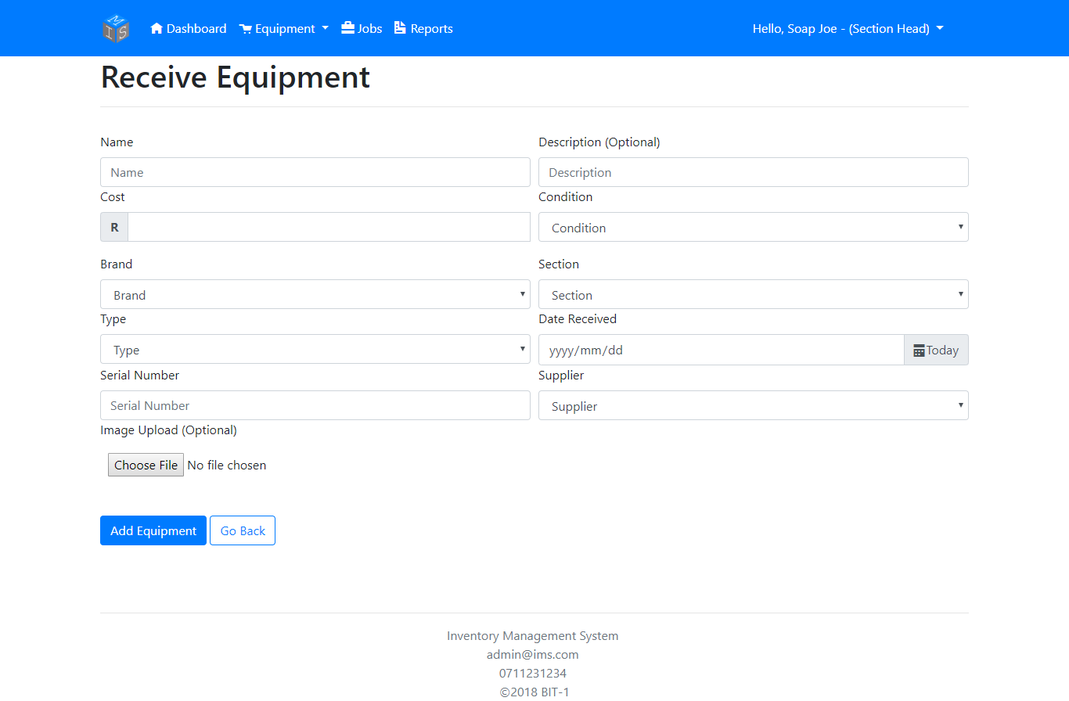

Choose an image to include when equipment is being received.

If the Equipment’s brand, type, Section, Condition, or Supplier doesn’t exist in the respected dropdown lists, you can add them separately by clicking the ‘Add New…’ at the bottom of the respected dropdown.

Enter a Serial Number that hasn’t been used. (You will get notified if Serial Number is unavailable)

Manage Equipment

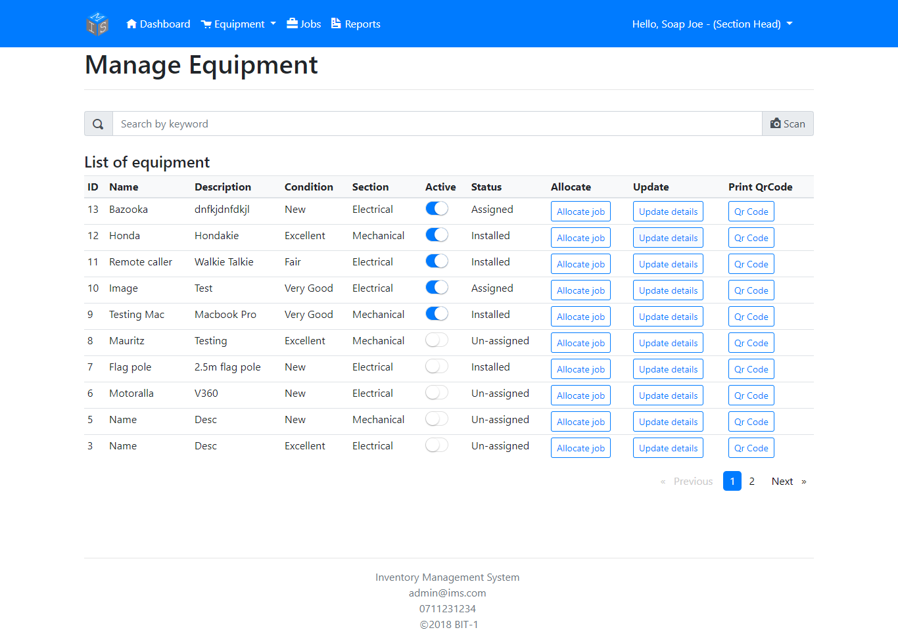

Enter equipment keyword to narrow results.

Press switch to activate/deactivate an equipment.

To get redirected to the page that will allow you to allocate a job to a user regarding the equipment.

To get redirected to the page that will allow you to update the equipment’s details.

To get redirected to the page that will allow you to export the equipment’s serial to a PDF.

Scan an equipment’s QR Code for a sudden result.

Save QR Code to PDF

QR code of a specific equipment (generated from the equipment’s serial).

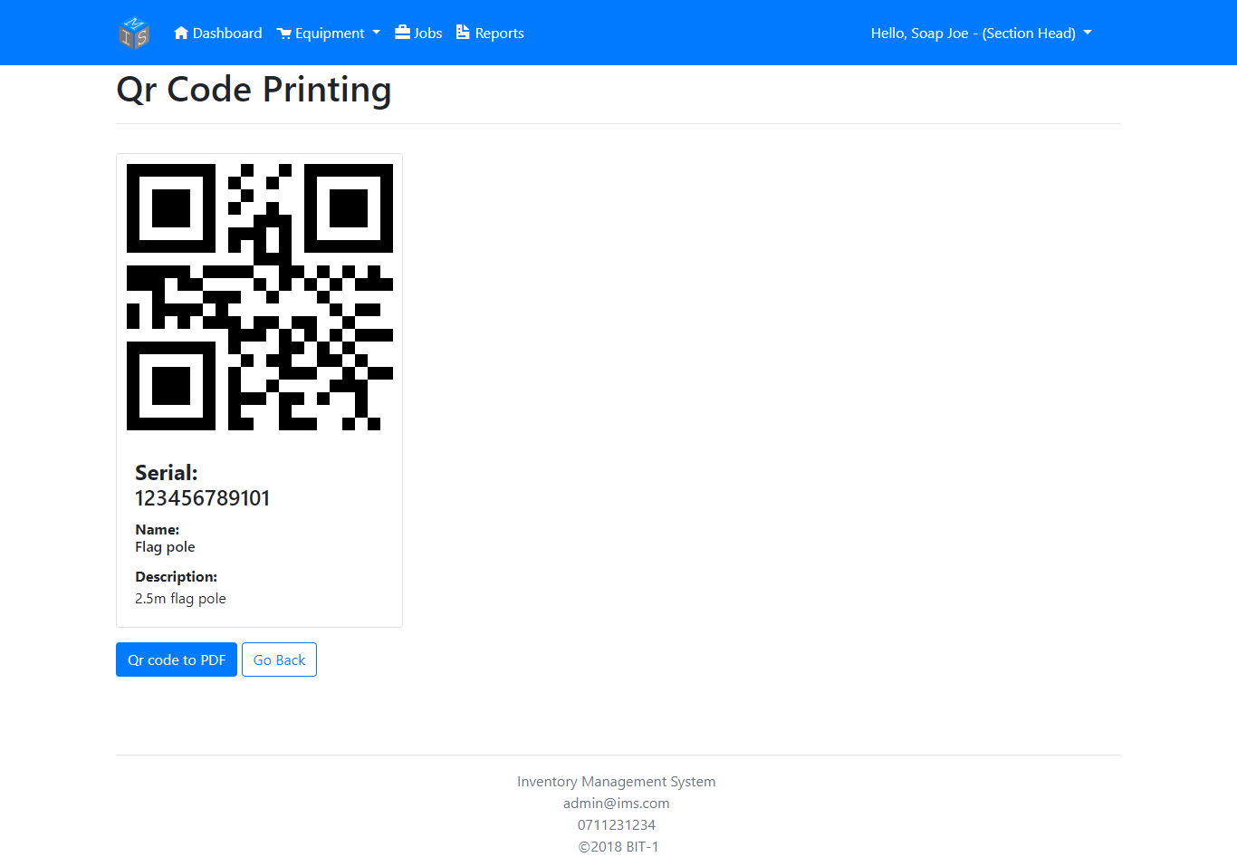

General information regarding the equipment.

Press this button to save the QR code above in form of a PDF file.

Allocate Job

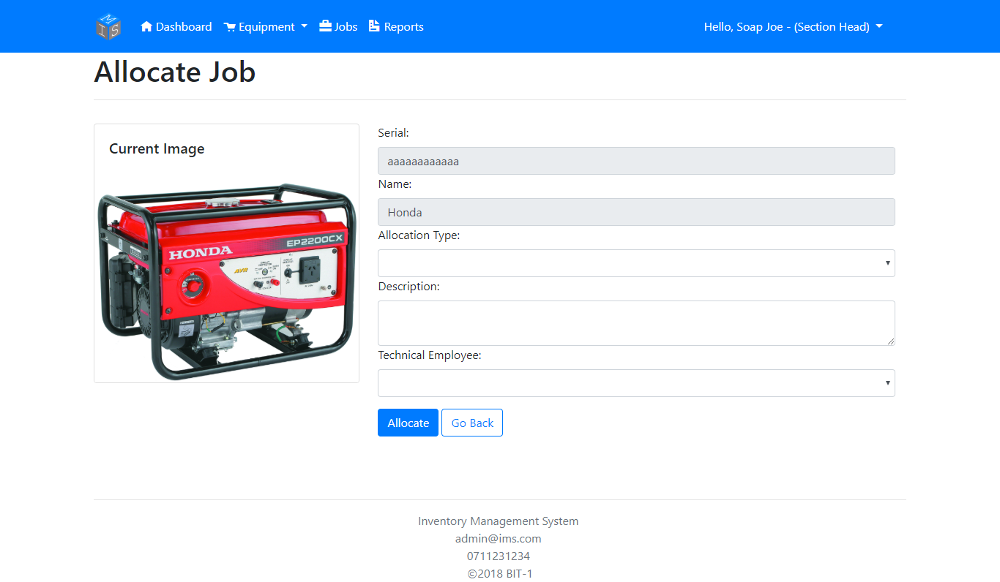

Select an Employee (only Technical Employees and Section Heads that are active will get loaded here) who’s going to receive the job.

Description regarding the jobs specifications must be entered here.

Type of job to be allocated must be selected from here.

Update Equipment Details

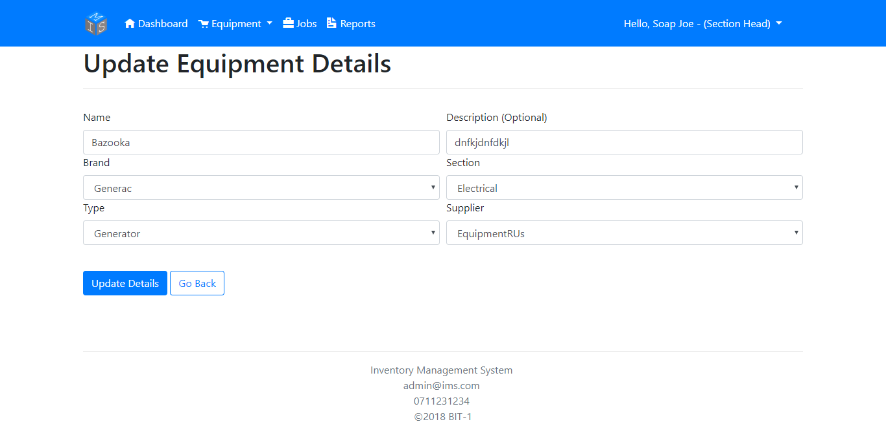

After you updated the necessary details, press the ‘Update Details’ to save the changes made.

If the Equipment’s brand, type, Section, or Supplier doesn’t exist in the respected dropdown lists, you can add them separately by clicking the ‘Add New…’ at the bottom of the respected dropdown.

Install Equipment

If marker isn’t 100% regarding location, you’re able to drag the marker to the desired location.

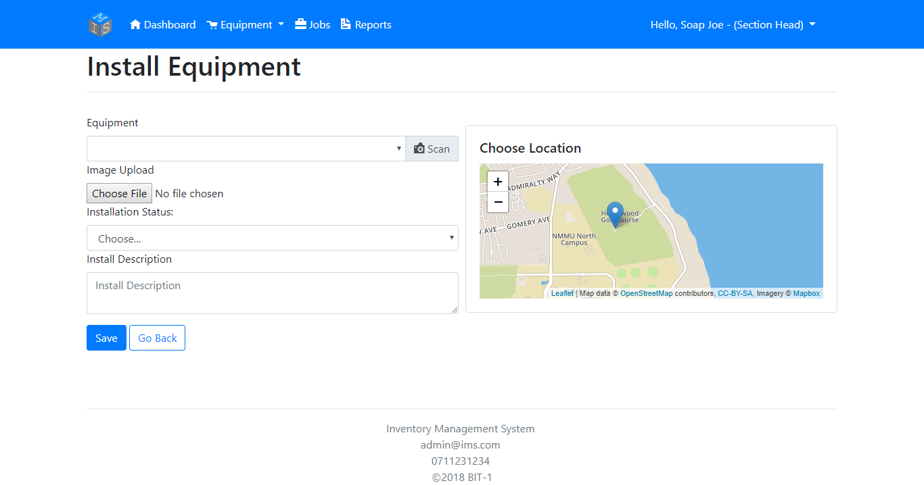

Select the Equipment or scan the equipment’s QR to select the equipment.

You can upload (take a picture if using a smartphone) an image of the equipment’s current condition.

If the map doesn’t load, it’ll be possible that at least one of the following errors might have occurred.

1. Your device has rejected access to your location. To fix, please enable Location on your device/browser.
2. Unable to determine your location.
3. Service timeout regarding connecting to the Mapbox server. To fix, please exit and re-enter the page to try and reconnect to the Mapbox server.
4. Browser not supported (Tested and works on Google Chrome, Mozilla Firefox, and Microsoft Edge. Internet Explorer not supportive.)

Select whether the Installation process is still Open or Closed.

Inspect Equipment

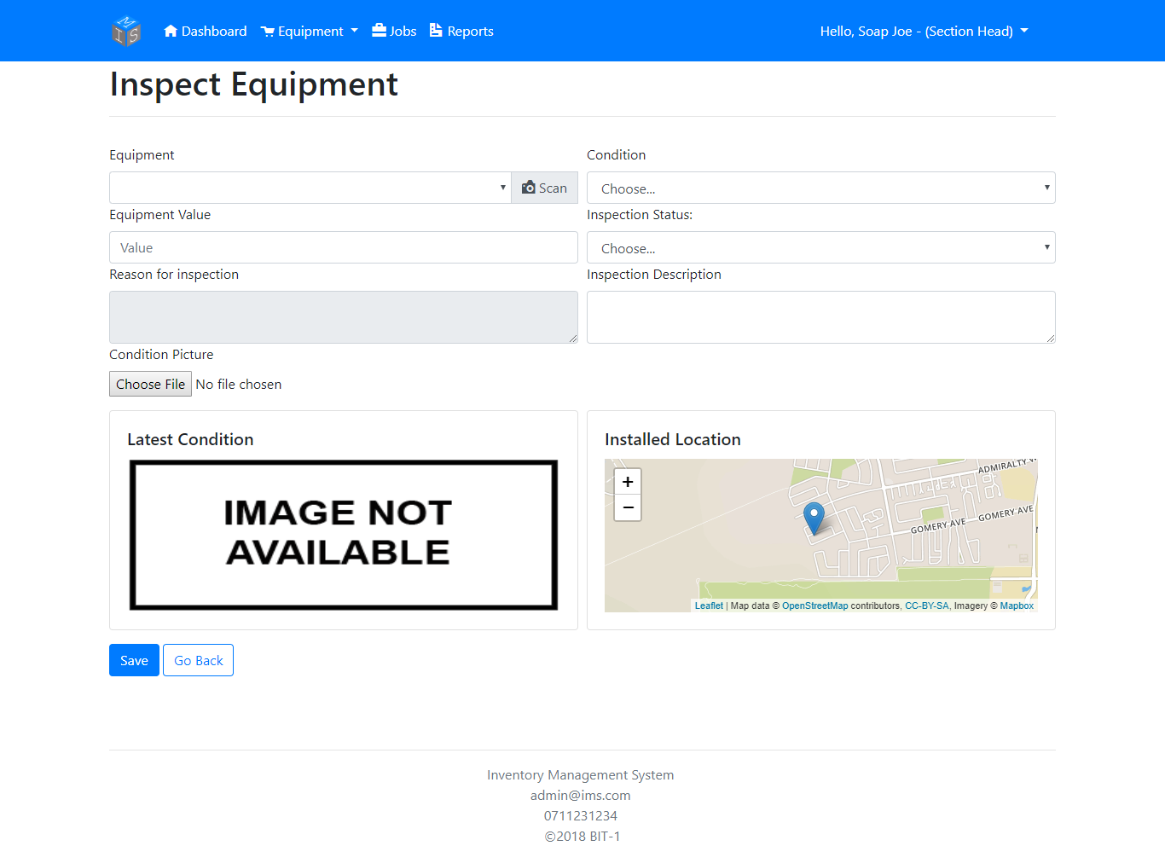

Take a picture or select an image to update the picture of the equipment’s current condition.

Update the Equipment’s value if necessary.

Select to pick the Equipment’s current Condition and to specify whether the Inspection Process is still open or closed.

Select the Equipment or scan the equipment’s QR to select the equipment.

If the map doesn’t load, it’ll be possible that at least one of the following errors might have occurred.

1. Your device has rejected access to your location. To fix, please enable Location on your device/browser.
2. Unable to determine your location.
3. Service timeout regarding connecting to the Mapbox server. To fix, please exit and re-enter the page to try and reconnect to the Mapbox server.
4. Browser not supported (Tested and works on Google Chrome, Mozilla Firefox, and Microsoft Edge. Internet Explorer not supportive.)

Maintain Equipment

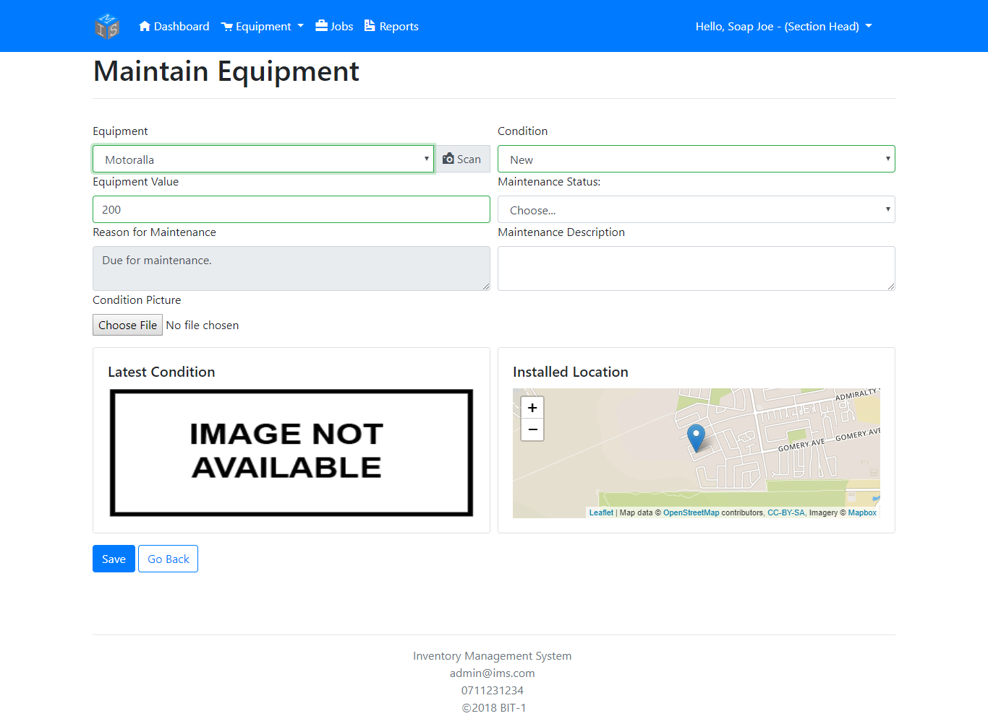

Take a picture or select an image to update the picture of the equipment’s current condition.

Select to update the Equipment’s current Condition.

Select to specify whether the Inspection Process is still open or closed.

Select the Equipment or scan the equipment’s QR to select the equipment.

Update the Equipment’s value if necessary.

If the map doesn’t load, it’ll be possible that at least one of the following errors might have occurred.

1. Your device has rejected access to your location. To fix, please enable Location on your device/browser.
2. Unable to determine your location.
3. Service timeout regarding connecting to the Mapbox server. To fix, please exit and re-enter the page to try and reconnect to the Mapbox server.
4. Browser not supported (Tested and works on Google Chrome, Mozilla Firefox, and Microsoft Edge. Internet Explorer not supportive.)

Allocated Jobs

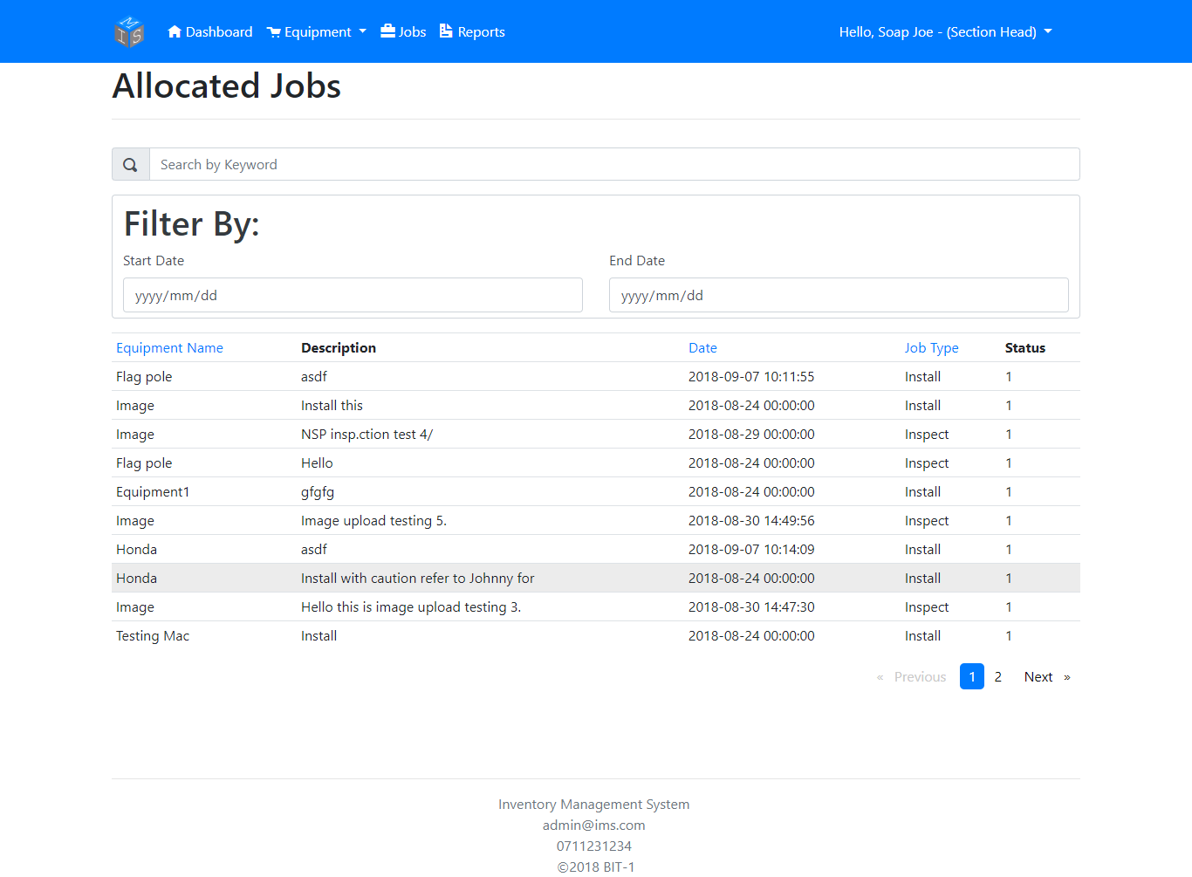

To search for a specific equipment or a type of allocated job by searching using a keyword.

To search for a job between two specific dates.

Generate Report

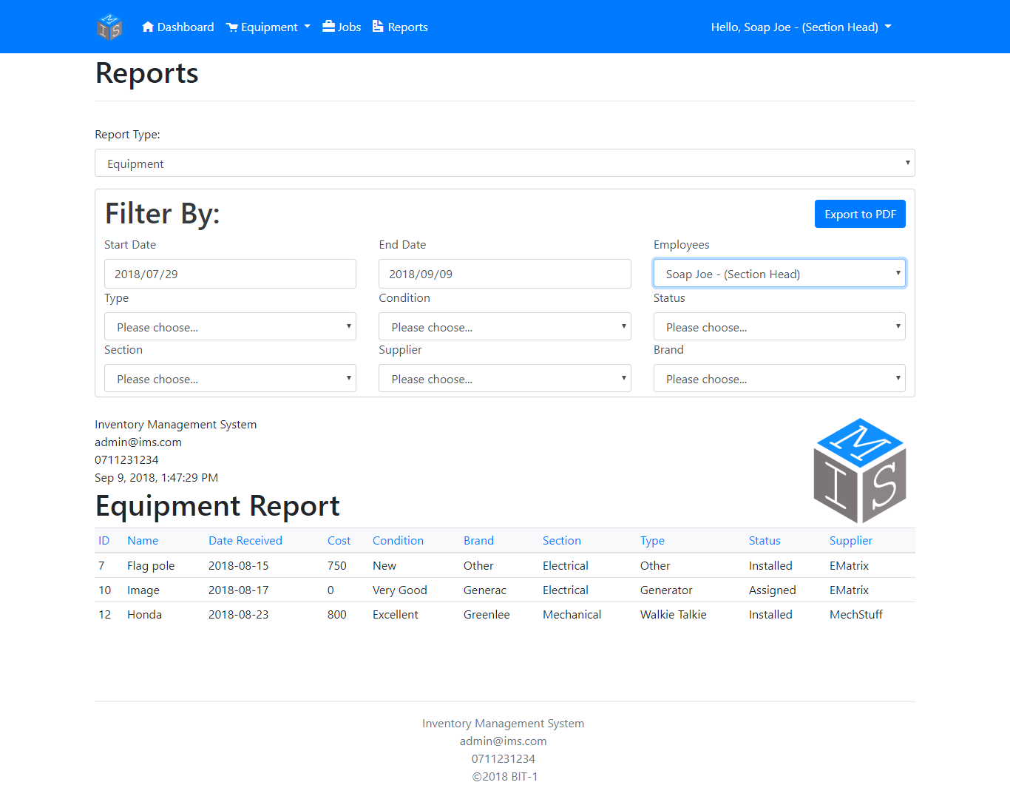

The user can export the Report to a PDF file.

The user can filter the report (depending on Report Type) to be more specific regarding their query.

The user can select whether they want to generate an equipment report or an equipment history report.